Th 2 Absolute measurements of electrical quantities

Solution

- After some time t, the normal to the coil plane makes an angle ω t with the magnetic field 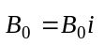. Then, the magnetic flux through the coil is
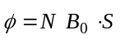
where the vector surface is given by 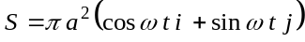
Therefore 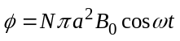
The induced electromotive force is
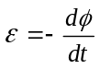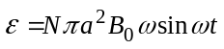
The instantaneous power is ε ² /R , therefore
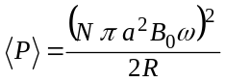
where we used 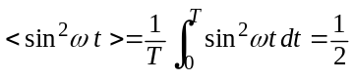

- The total field at the center the coil at the instant t is
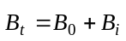
where 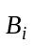 is the magnetic field due to the induced current 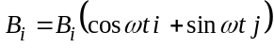
with 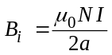 and I = ε / R
Therefore 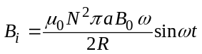
The mean values of its components are
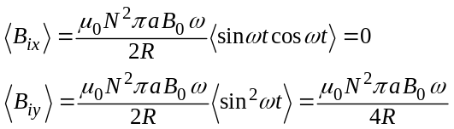
And the mean value of the total magnetic field is
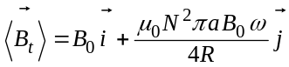
The needle orients along the mean field, therefore
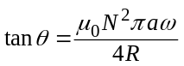

Finally, the resistance of the coil measured by this procedure, in terms of , is
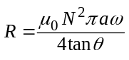
3. The force on a unit positive charge in a disk is radial and its modulus is
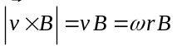
where B is the magnetic field at the center of the coil
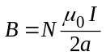
Then, the electromotive force (e.m.f.) induced on each disk by the magnetic field B is
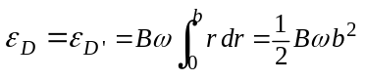
Finally, the induced e.m.f. between 1 and 4 is ε = ε_{D} + ε _{D'}
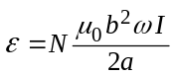

4. When the reading of G vanishes, 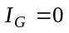 and Kirchoff laws give an immediate answer. Then we have
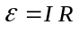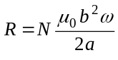

5. The force per unit length f between two indefinite parallel straight wires separated by a distance h is.
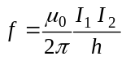
for 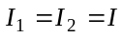 and length 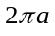, the force F induced on C₂ by the neighbor coils C₁ is
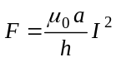

6. In equilibrium
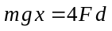
Then
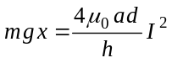 (1)
so that
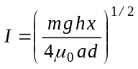

- The balance comes back towards the equilibrium position for a little angular deviation δϕ if the gravity torques with respect to the fulcrum O are greater than the magnetic torques.
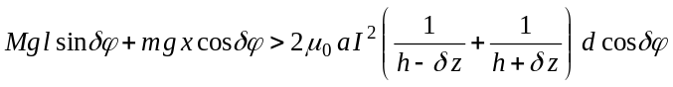
O
l
x
δϕ
δϕ
δ z
h + δ z
h - δ z
h + δ z
h - δ z
Mg
mg
d
G
Therefore, using the suggested approximation
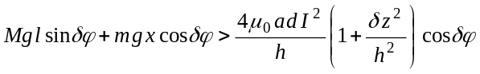
Taking into account the equilibrium condition (1), one obtains
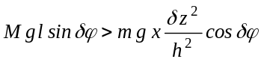
Finally, for 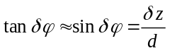
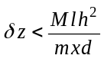 ⇒ 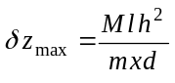

Th 2 ANSWER SHEET

Question | Basic formulas and ideas used | Analytical results | Marking guideline
1 | 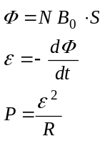 | 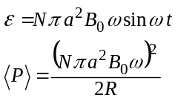 | 0.5  1.0
2 | 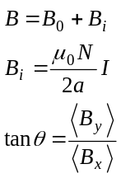 | 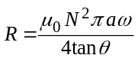 | 2.0
3 | 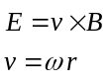  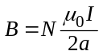  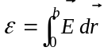 | 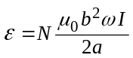 | 2.0
4 | 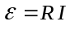 | 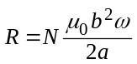 | 0,5
5 | 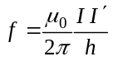 | 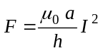 | 1.0
6 | 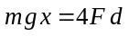 | 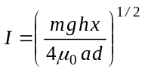 | 1.0
7 | 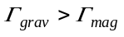 | 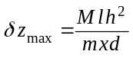 | 2.0

